**MECE308 Project Description, 2024-2025 (II)**

**PENDULA SYSTEM TO GENERATE ELECTRICITY FROM OCEAN/SEA WAVES**

Electricity power generation from waves has an immense potential to contribute to our electric energy production, and today, many wave power projects are close to being commercialized. Research on this subject has been increasing in recent years. Therefore, this project focuses on obtaining electricity from ocean/sea wave energy by using a pendula system.

The pendula is shaped like a rectangular box with one side opening to the sea. A pendulum flap is hinged over this opening (Figure 1). The flap moves back and forth with the wave motion.

The cross-section of the wave geometry used in the project is assumed to be a right triangle, height 0.4 m, width 1 m (Figure 2). The wave frequency and velocity that hit the flap are 10 seconds and 1.5 m/s, respectively. The opening of the rectangular box parallel to the coast will be 5 m.

In the project, electrical energy will be obtained from the rotation of a generator (Figure 3). A mechanism will be used to convert the back-and-forth motion of the pendulum flap into a unidirectional rotary motion. A gearbox is used to increase the speed of the generator. A flywheel is strongly recommended to stabilize the rotational motion (energy) (Figure 3).

The project aims to design a system producing the highest electrical power.

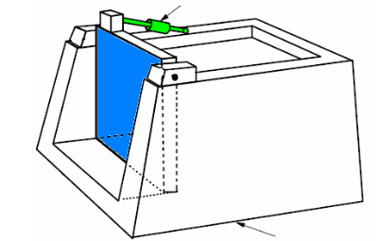

Figure 1 A pendula flap and rectangular box

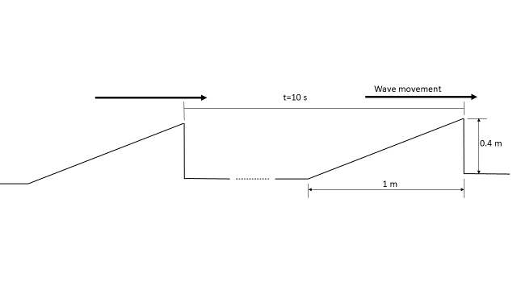

Figure 2 Waveform to be used in the project

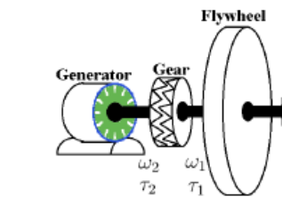

Figure 2 Use of flywheel in stabilization of rotational energy/motion

Project studies will include;

1. Design of the rectangular box and detail design of mounting/assembly to the shore,

2. Design of the pendulum flap and its' connection details to the rectangular box,

3. Design of a mechanism to convert the back-and-forth motion of the pendulum flap into a continuous unidirectional rotational motion,

4. Design of the flywheel to stabilize the speed of the rotational movement,

4. Design of the gearbox to increase the speed of the rotational movement,

5. Selection of the generator to convert the rotational motion from the gearbox into electrical energy

6. Connection details between the generator and the gearbox.

MECE308 PROJECT EVALUATION POLICY

|  |  |
| --- | --- |
| **CONTENT** | **Grade point** |
|
| **Title Page** | **1** |
| **ABSTRACT** | **3** |
| **Table of Contents** | **1** |
| **List of Figure** | **1** |
| **List of Tables** | **1** |
| **INTRODUCTION** | **6** |
| Project Definition | 3 |
| Projects Objectives | 3 |
| **LITERATURE REVIEW** | **10** |
| Project Background | 2 |
| Previous Work | 4 |
| Comparative Work | 4 |
| **SYSTEM DESIGN and MANUFACTURING** | **55** |
| Design Constraints and Design Methodology | 5 |
| Engineering Design and Manufacturing Standards | 5 |
| Product Subsystems, Design Calculations, Selection of Components | 35 |
| Technical drawing of the system assembly (simple) | 10 |
| **PROJECT MANAGEMENT** | **9** |
| Project Plan (Gantt chart) | 2 |
| Contribution of Team Members | 2 |
| Challenges and Decision-Making | 2 |
| Project Bill of Materials | 3 |
| **LIFELONG LEARNING** | **8** |
| **CONCLUSIONS and FUTURE**  **RECOMMENDATIONS** | **3** |
| **REFERENCES** | **2** |
| Neatness, clarity and English use in project report | **10** |
| OVERALL | **110** |