MECE308 Project Description
2025-2026 (II)

Sightseeing Pedal Pub Bike with Beverage Bar

Project Description
This project involves the design and development of a Sightseeing Pedal Pub Bike equipped with a beverage-serving bar. The vehicle will be primarily human-powered during sightseeing tours, with an auxiliary electric drive system used only for positioning and low-speed maneuvering. The design must prioritize low total weight, minimum electric power consumption, and overall cost efficiency, while maintaining structural safety and user comfort.

General Specifications
- Capacity
  - 6 pedalers (total estimated weight: 450 kg)
  - 1 driver (estimated weight: 75 kg)
- Operation Modes
  - Sightseeing mode: Vehicle is powered solely by pedaling. No electric power will be engaged during normal operation.
  - Positioning/transport mode: The driver can operate the vehicle using the electric motor to reach the starting point or for operational adjustments.
- Speed Limit
  - Maximum speed in both pedaling and electric-assisted modes: 30 km/h.
  - Sightseeing, whether in pedaling or electric-assisted mode, will take place on zero-slope paths.
- Drive System
  - An electric motor powered by a rechargeable battery.
  - A custom-designed gearbox will reduce motor speed to the required wheel speed.
(Commercial motor–gearbox assemblies must not be used.)
  - The battery capacity allows 2 hours of operation under electric drive.
  - Motor speed—and correspondingly vehicle speed—will be controlled by regulating motor RPM.
No mechanical gear shifting.
- Chassis & Body
  - Four-wheel configuration for stability.
  - Frame/chassis constructed from box-profile steel beams or aluminum box profiles.
  - Seat pedals will incorporate an idle/freewheel mechanism to allow coasting.
  - A lightweight overhead shade canopy will be installed to improve passenger comfort.
- Additional Mechanical Considerations (added for completeness)
  - Steering system designed for safe low-speed maneuverability (likely front-wheel steer).
  - Braking system suitable for full-load conditions, such as hydraulic or mechanical disc brakes.
  - A chain-drive system linking each pedal station to the main drive shaft.
  - Vibration and noise-damping elements where applicable.
  - Beverage bar mounted centrally with secure cupholders and spill-resistant surfaces.

Project Report Requirements
The final submitted report must include:
- Conceptual Design
  - Overall layout, aesthetics, user placement, and system functionality.
- Mechanical Design and Analysis
  - Structural design of the frame and supports.
  - Strength calculations for beams, joints, and load-bearing components.
  - Pedal drive system design, shaft analysis, and drivetrain layout.
  - Finite element analysis (if applicable).
- Selection of Commercial Components
  - Battery, electric motor (without gearbox), brake system, steering components.
  - Seats/saddles, pedals, chain, sprockets, clutch mechanism, wheels, lighting, etc.
- Gearbox Design
  - Complete design of a speed-reducing gearbox for the electric motor.
  - Gear ratio calculations, material selection, and performance analysis.
- Connection & Assembly Drawings
  - Detailed technical drawings showing:
    - Part connections
    - Welds, bolts, joints
    - Subsystem integration
  - Fully assembled system drawing.

Reference Images
Photos of an existing 12-person pedal pub bike (engine-driven model with non-functional pedals) are provided for reference and comparison.

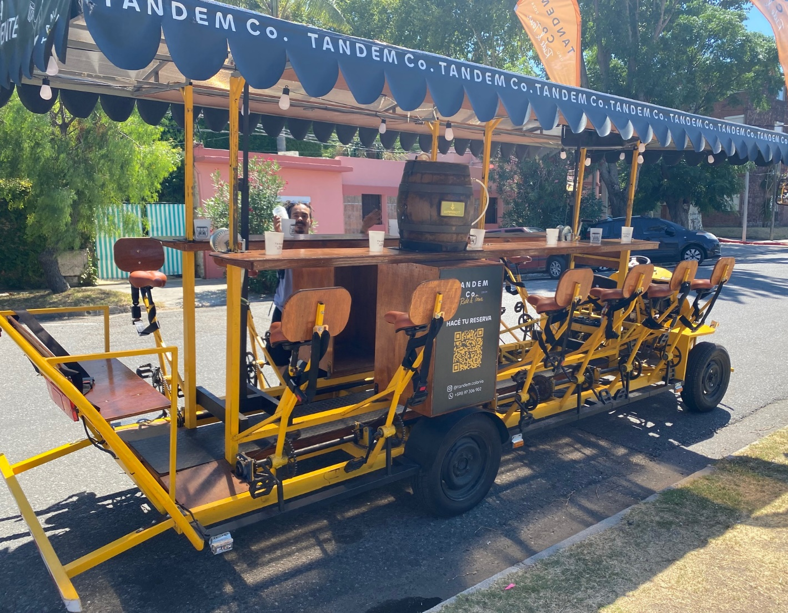

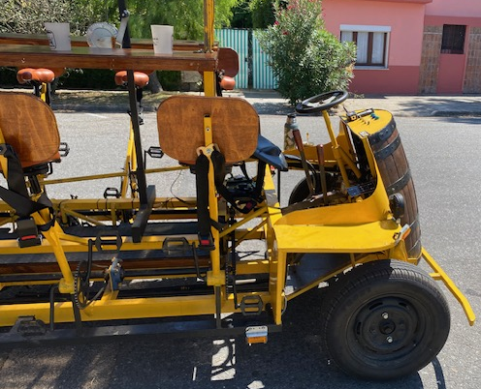

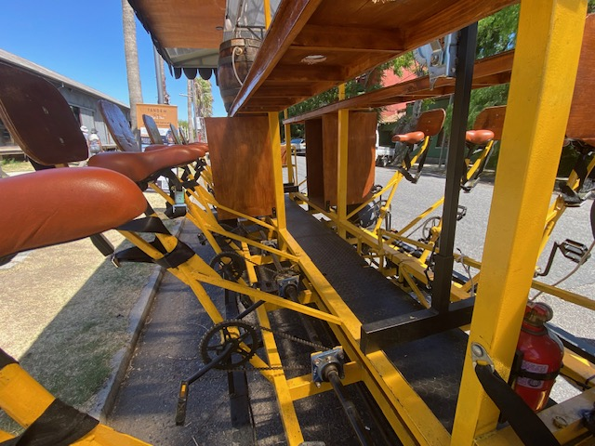
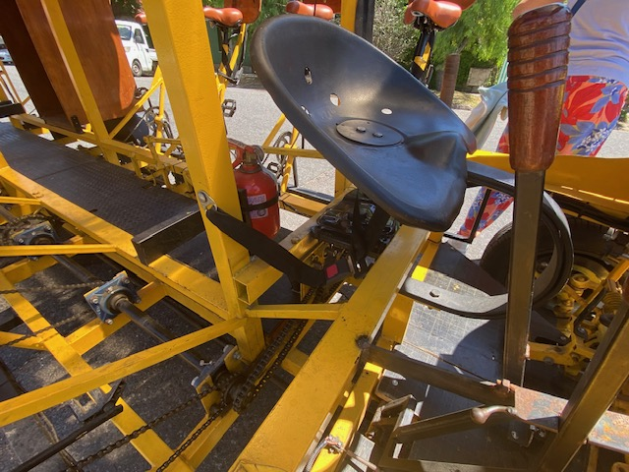

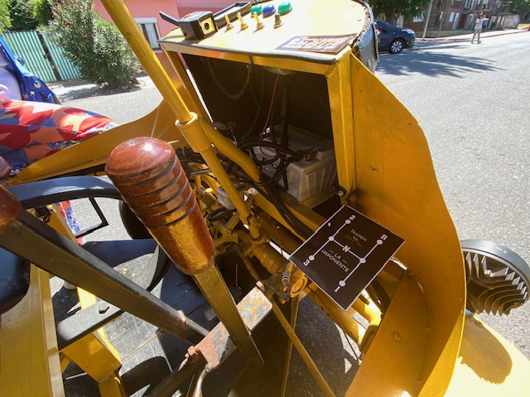
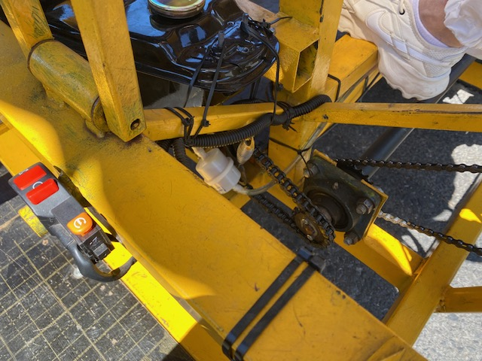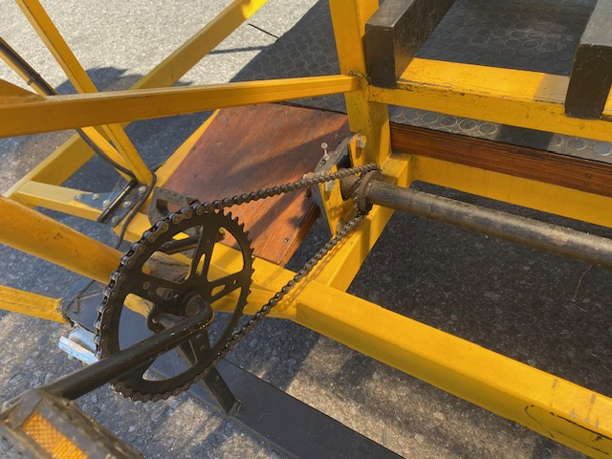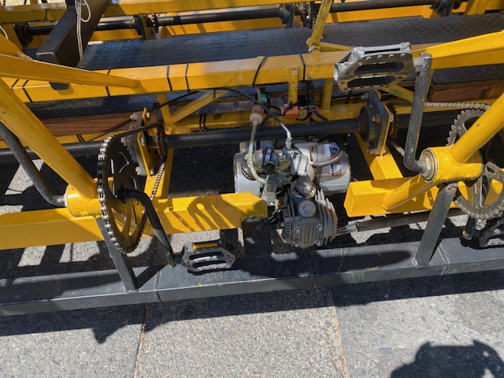

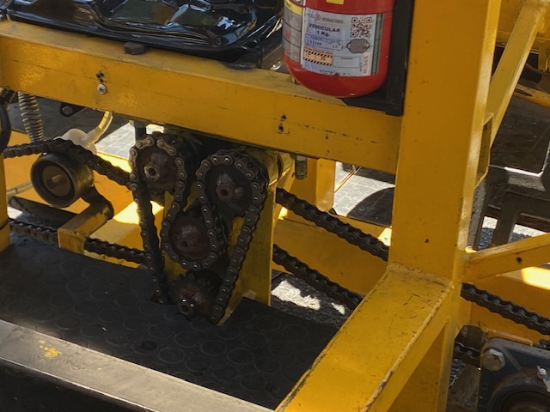

PROJECT EVALUATION POLICY
CONTENT | Grade point | G1 | G2 | G3 | G4 | G5 | G6 | G7
Title Page | 1
ABSTRACT | 3
Table of Contents | 1
List of Figure | 1
List of Tables | 1
INTRODUCTION | 6
Project Definition | 3
Projects Objectives | 3
LITERATURE REVIEW | 10
Project Background | 2
Previous Work | 4
Comparative Work | 4
SYSTEM DESIGN and MANUFACTURING | 55
Design Constraints and Design Methodology | 5
Engineering Design and Manufacturing Standards | 5
Product Subsystems, Design Calculations, Selection of Components | 35
Technical drawing of the system assembly (simple) | 10
PROJECT MANAGEMENT | 9
Project Plan (Gantt chart) | 2
Contribution of Team Members | 2
Challenges and Decision-Making | 2
Project Bill of Materials | 3
LIFELONG LEARNING | 8
CONCLUSIONS and FUTURE  RECOMMENDATIONS | 3
REFERENCES | 2
Neatness, clarity and English use in project report | 10
OVERALL | 110

